**WORKING WITH DATASET**

|  |  |
| --- | --- |
| Date | 14 November 2022 |
| Team ID | PNT2022TMID28787 |
| Project Name | Visualizing and Predicting Heart Diseases with an Interactive Dash Board |

Exploration Of BP vs Chest Pain Type and Gender

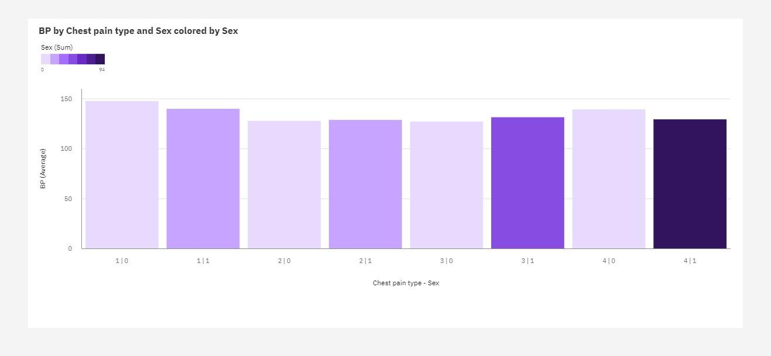

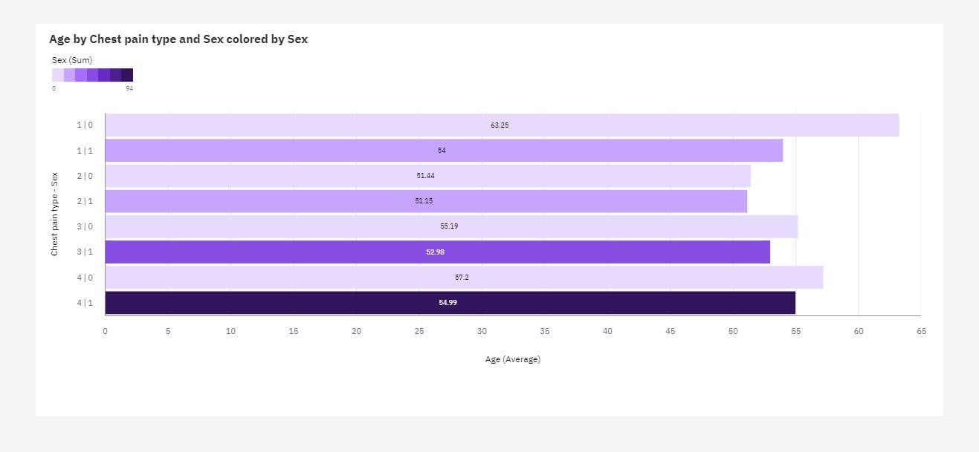

**Exploration Of Max Heart Rate During The Chest Pain**

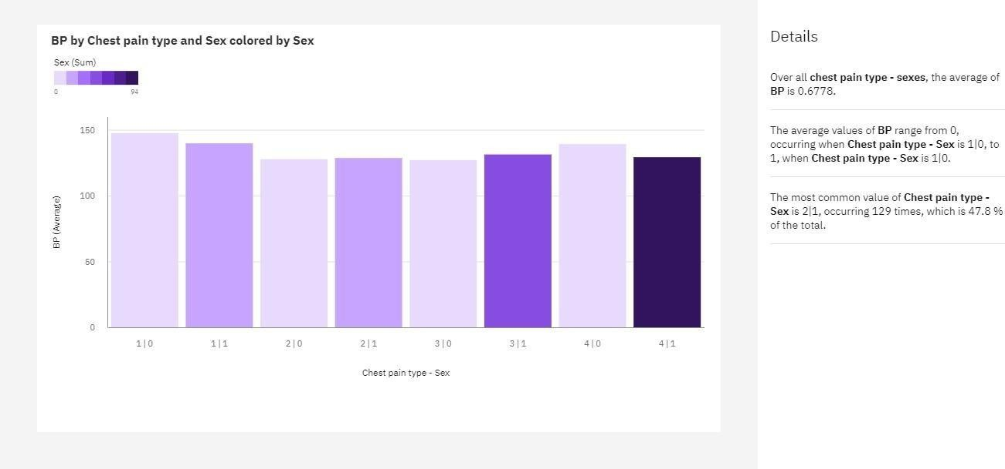

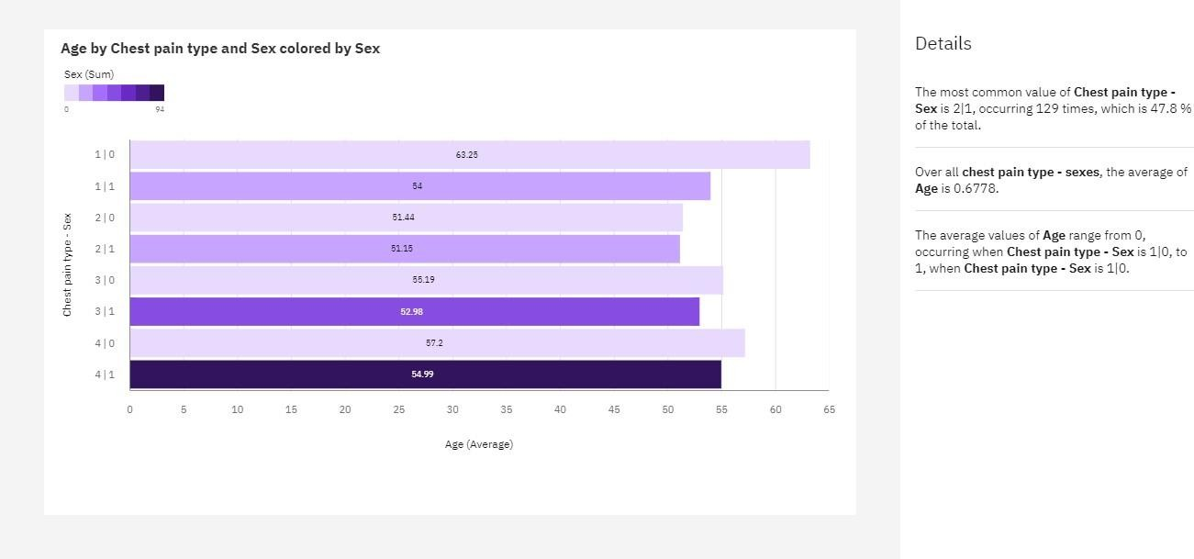

Exploration Of BP By Age

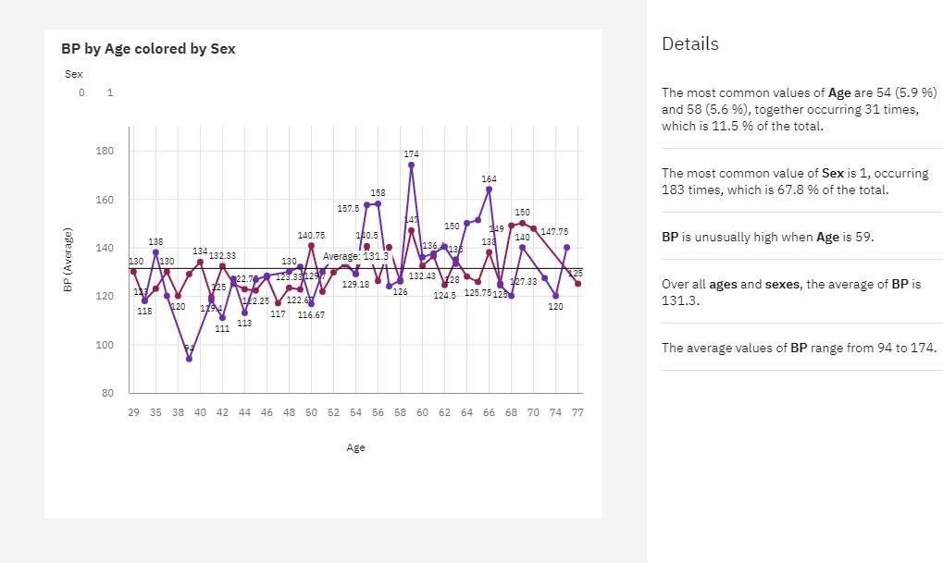

Exploration Of Chorestrol By Age And Gender

